Q 5c from “Midterm Reviews”:

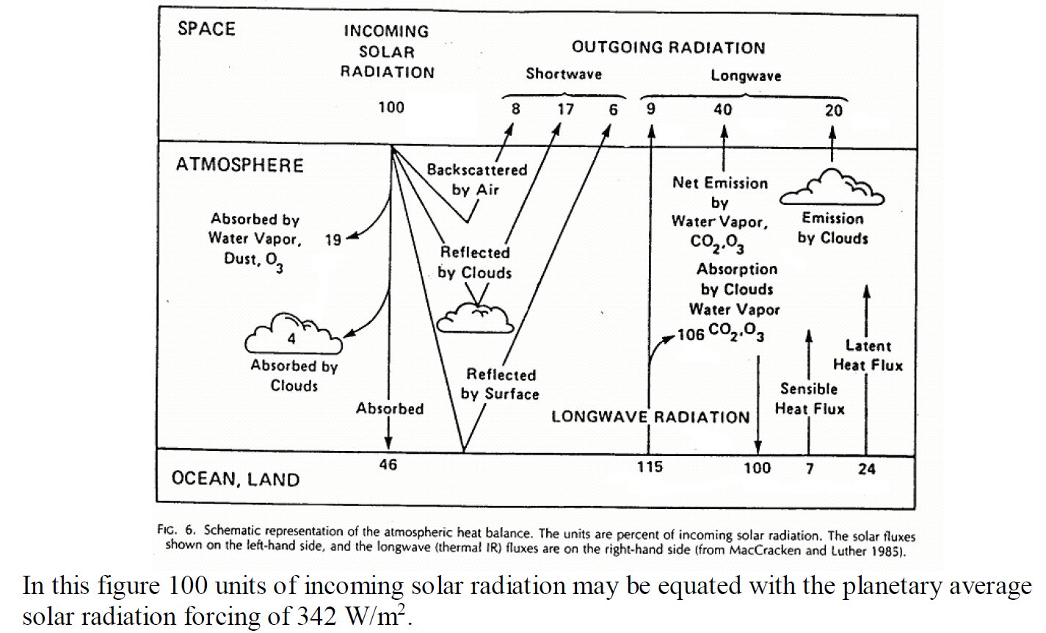

(c) Calculate the surface radiative temperature (a planetary average).

**Solution for 5c:**

The planetary average of radiative energy from the ocean and earth system = (6+115)/100*342 W/m2 = 413.82 Wm-2.

Radiative energy from the surface (equation 3B1-2 of Dingman 2nd edition,

$$\frac{q}{A}=σ.{T_{P}}^{4}…………………………..(i)$$

$${T_{P}}^{4}=\frac{q/A}{σ}=\frac{413.82 Wm^{-2}}{5.67×{10}^{-8}Wm^{-2}K^{-4}}=7298.413 K^{4}$$

$T_{P}=292.29 K$ = 19.14°C

**Q 6b from “Midterm Reviews”:**

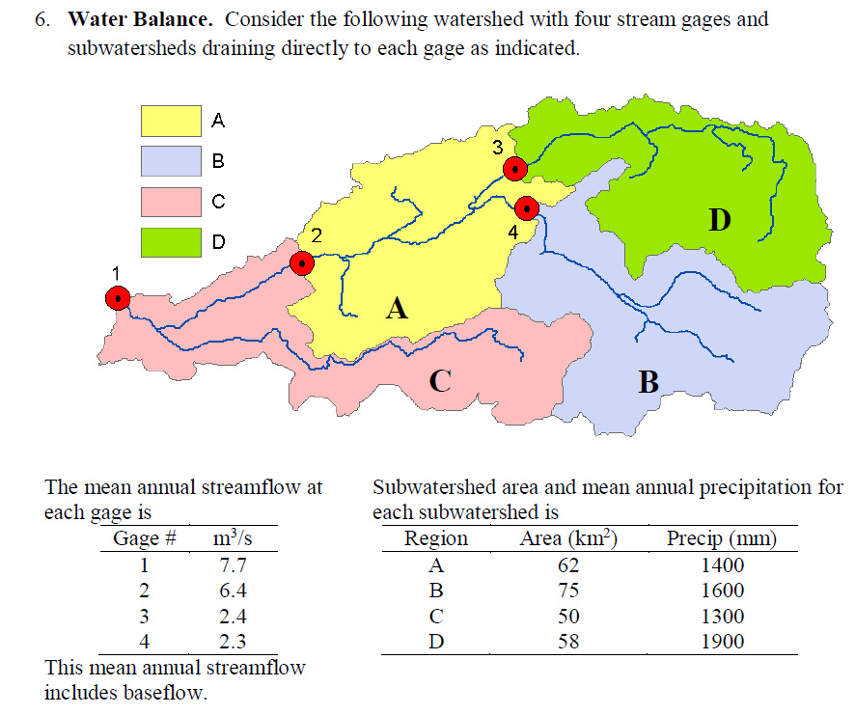

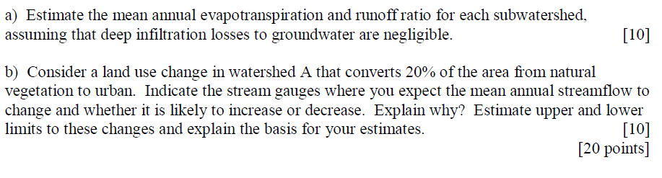

**Solution for 6b:**

If we consider a land use change in watershed A that converts 20% of the area from natural vegetation to urban, stream gauges 2 and 1 are expected to have lower mean annual streamflow than before. Because with urbanization more areas will be paved which will decrease infiltration and increase surface runoff in catchment A.

I do not have any clue to estimate the upper and lower limits to these changes. Can you give me some direction to this?

From doing part (a) you have estimated the direct runoff from A and a runoff ratio from A. In a worst case scenario you get 100% runoff from the 20% area that is urbanized. This gives an upper bound on your estimate. At the other end of the scale you may have complete capture of rainfall in the urban area (runoff ratio go to 0). Really intensive rainwater harvesting and green infrastructure could achieve this. You still have the same runoff and runoff ratio from the 80% that is assumed to be unchanged. This can give you a lower bound.